Imagine that we have the following regression equation: $y=β_{0}+β_{1}x+ε$.

In the equation above, *y* is the dependent variable, *x* is the predictor, $β_{0}$ is the population y-intercept, $β_{1}$ is the population slope parameter, and $ε$ is the residual term – that is, the term which allows the population regression line to fall above or below actual data points. Said differently, $ε$ is the difference between observed values of *y* and the values of *y* predicted by the regression model (denoted by $\hat{y}$).

We first estimate ${\hat{β}}_{0}$ and ${\hat{β}}_{1}$ by minimizing the sum of squared residuals, $SSE=\sum_{i=1}^{n}{ε^{2}}$.

Recall that ${\hat{β}}_{0}$ and ${\hat{β}}_{1}$ are quantities calculated from sample data, and are point estimators of the true corresponding population parameters, $β_{0}$ and $β_{1}$.

After we estimate ${\hat{β}}_{0}$ and ${\hat{β}}_{1}$ using our sample data, we can do hypothesis tests. For example, below is a test about the $β_{1}$ parameter:

${H_{0}: β}_{1}=0$ vs.

$${{ H}_{a}: β}_{1}≠0$$

Because ${\hat{β}}_{1}$ is a quantity calculated from sample data, if we were to have an infinitely large number of samples drawn from the population when the $H_{0}$ is true (i.e., where $β_{1}=0)$, we would have a bunch of different values of ${\hat{β}}_{1}$ (i.e., each sample would have its own value). That is, we could think of ${\hat{β}}_{1}$ as a random variable whose values vary from sample to sample, and whose values have a distribution of their own. If $H_{0}$ is true and $β_{1}=0$, the distribution of ${\hat{β}}_{1}$ might look like this:

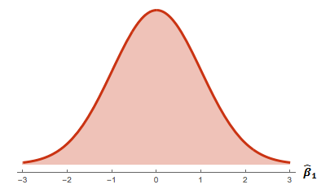

Notice that the distribution looks normal, and is centered around 0. That is, $E\left({\hat{β}}_{1}\right)=β_{1}$– i.e., the expected value, or *true population average*, of $\hat{β}$ is $β_{1}$ (which, under $H_{0},$ is 0).

We know that when $H_{0}$ is true (i.e., when $β_{1}=0)$, the quantity

$$\frac{{\hat{β}}_{1}-E\left({\hat{β}}_{1}\right)}{SD\left({\hat{β}}_{1}\right)}=\frac{{\hat{β}}_{1}-0}{SD\left({\hat{β}}_{1}\right)}=\frac{{\hat{β}}_{1}}{SD\left({\hat{β}}_{1}\right)}=\frac{{\hat{β}}_{1}}{\sqrt{\frac{\frac{SSE}{n-2}}{\sum_{i=1}^{n}{{\left(x_{i}-\overline{x}\right)}^{2}}}}}$$

has a t-distribution with *n – 2* degrees of freedom, where *n* is the sample size.

So, we can calculate the t-statistic using the formula above, and then obtain the p-value, which is the probability of obtaining the ${\hat{β}}_{1}$ that is as different from 0 (value stated in $H_{0}$) as the one we obtain in our sample.

We can also calculate the 95% confidence interval for $β_{1}$ using the following formula:

$${\hat{β}}_{1}±t_{0.025, n-2}∙SD\left({\hat{β}}_{1}\right)={\hat{β}}_{1}±t_{0.025, n-2}∙\sqrt{\frac{\frac{SSE}{n-2}}{\sum_{i=1}^{n}{{\left(x_{i}-\overline{x}\right)}^{2}}}}$$

For our intents and purposes, the calculation of the t-statistic, the p-value, and the confidence intervals will be done in R.

However, it is worth noting that the reason statisticians like to have confidence intervals is that they can have a range of plausible values for our population parameter $β_{1}$, instead of just a single estimate, ${\hat{β}}_{1}$.

The 95% confidence interval may be interpreted as follows: if we were to have an infinitely large number of samples, each with its own value of ${\hat{β}}_{1}$, and we were to construct 95% confidence intervals for $β_{1}$ from each sample, then 95% of the resulting confidence intervals would contain the true population parameter $β_{1}$ and the remaining 5% would not. Since we are dealing with a single sample, we do not know whether our sample is part of the 95% of the samples that contain the true value of $β_{1}$, or part of the 5% of the samples that don’t, but if it’s part of the 5%, we can simply consider ourselves unlucky.

In the figure below, we have a bunch of samples drawn from the population where $β_{1}=0$ (i.e., when the $H_{0}$ is true). Each little square below the histogram of ${\hat{β}}_{1}$ represents the value of ${\hat{β}}_{1}$ from each sample. The “whiskers” represent the 95% confidence interval for each sample. If we were to have a very large number of samples (and not just 10) then 95% of all the confidence intervals would not contain $β_{1}=0$, the true population value under $H_{0}$.

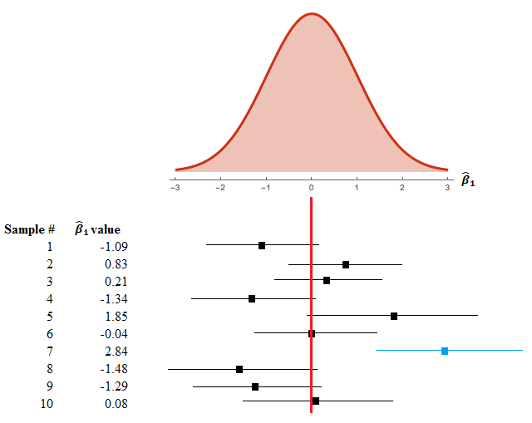

Another thing worth noting: if 0 is part of the 95% confidence interval, then we will *not* be able to reject ${H_{0}: β}_{1}=0$ at the level α = 0.05 significance level.

On the other hand, if 0 is *not* part of the 95% confidence interval, then we will be able to reject ${H_{0}: β}_{1}=0$ for ${H_{a}: β}_{1}≠0$ at the level α = 0.05 significance level.